Akashdeep Vasisht

LAB 3 PART 1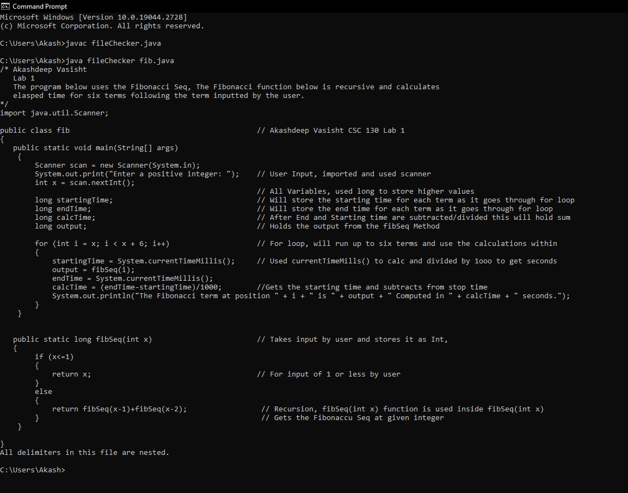

LAB 3 PART 2